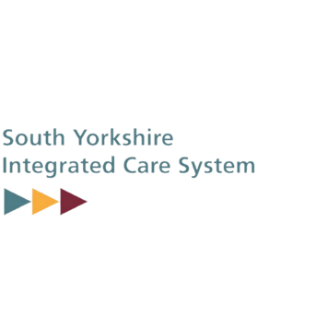
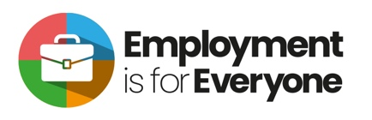
ICB Employment Group – Things to share with local people and organisations.

Access to Work:
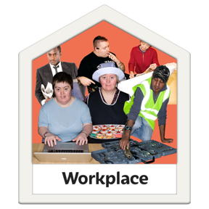
Access to Work is help you can get from the Department for Work and Pensions. Access to Work can help you get or stay in work if you have a physical or mental health condition or disability.
Website link:
https://www.gov.uk/government/publications/access-to-work-factsheet/access-to-work-factsheet-for-customers

Easy Read Link: https://assets.publishing.service.gov.uk/government/uploads/system/uploads/attachment_data/file/1144992/easy-read-access-to-work.pdf

Integrated Care System NHS 5 Year Plan
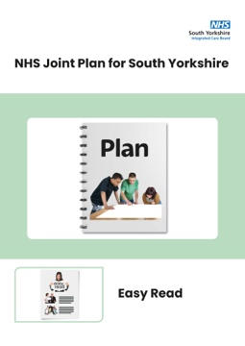
Our 5 year plan says that we will increase the number of jobs available to people with learning disabilities and autistic people by 25%.

Website link:
https://southyorkshire.icb.nhs.uk/about-us/our-structure/five-year-joint-forward-plan

Easy Read Link: https://syics.co.uk/application/files/7216/9088/5743/ICB_NHS_5_Year_Plan_Easy_Read_final.pdf

